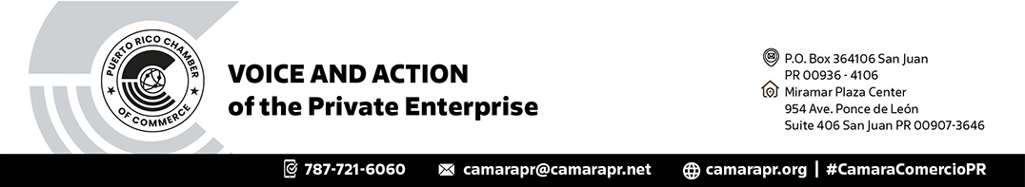
CERTIFICATE OF ORIGIN

INVOICE # 123456 (Escriba el número de la factura)
INVOICE DATE # 01/23/2019 (Escriba la fecha que aparece en la factura

I, the undersigned, Authorized Representative of Puerto Rico Chamber of Commerce, an association duly organized under the laws of Puerto Rico, do hereby

CERTIFY

That the article or merchandise described in the enclosed invoices, shipped by:
(Name and address of Shipper/Exporter):

JUAN DEL PUEBLO, INC.
URB. PLATANO
000 CALLE DEL PUEBLO
SAN JUAN PR 00901

and consigned to:
(Name and address of Consignee):

CASA DE BARRO CHINA, INC.
123 CALLE TOKIO
33422 TOKIO CHINA

is a Product of Puerto Rico, U.S.A.
Given at San Juan, PR, this day of 20

Authorized Representative
PUERTO RICO CHAMBER OF COMMERCE

WE CERTIFY THAT THE ARTICLE OR ARTICLES COVERED BY THIS CERTIFICATED ARE PRODUCE IN SAN JUAN, PUERTO RICO.

SIGNED:
(PLEASE, SIGN IN BLUE PEN)

